# INTRODUCTION

* 1. Overview

The flight accident is defined as an occurrence associated with the operation of an aircraft, which takes place from the time any person boards the aircraft with the intention of flight until all such persons have disembarked and in which a)a person is seriously injured b)the aircraft sustains significant damage or structural failure c)the aircraft goes missing. This aircraft analysis is a detailed investigation into the causes of an aviation accident. The dataset set is collected through Kaggle and reported as data visualizations like dashboard and story using tableau.

* 1. Purpose

Understanding what factors cause airplane crashes helps aviation industries make continuous improvement in flight safety, preventing future accidents and help to raise customer confidence with the use of statistical evidence.

# Problem Definition & Design Thinking

* 1. Empathy Map

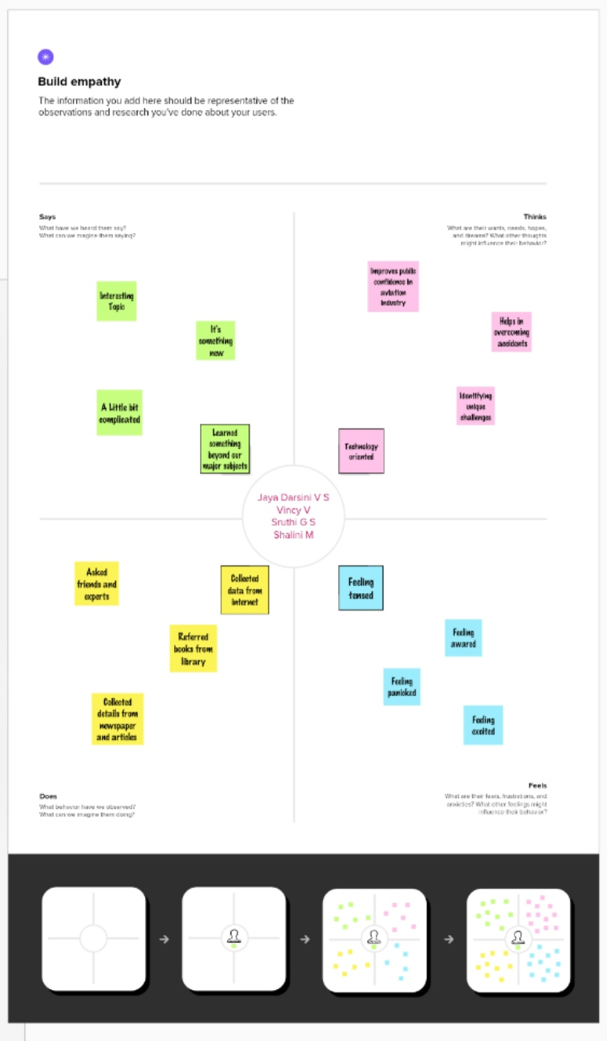

* 1. Ideation & Brainstorming Map

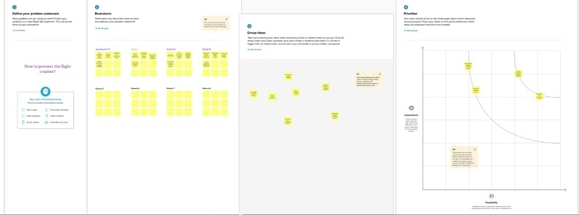

# RESULT

# *We created this data visualization using the dataset provided*

# Dashboard 1

# Dashboard 1.png

# Dashboard 2

# Dashboard 2.png

# Dashboard 3

# Dashboard 3.png

# Dashboard 4

# Dashboard 4.png

# Story

# Story 1.png

# ADVANTAGES&DISADVANTAGES

**Advantages:**

* The solution build a perfect confidence among public which promotes the financial status of aviation industry.
* Usage of highly advanced technologies helps to reduce the flight crash.

**Disadvantages:**

* The use of the highly advanced techniques may be fund rising and not affordable.
* Through our solutions we could not totally guarantee for the rapid decrease in the accident rate.

# APPLICATIONS

This can be widely used in the safety and emergency technical department who regulates the technical side of the aircrafts.

# CONCLUSION

# The cause of this accident is the combination of several factors, ambiguously written procedures, inadequate training, unexpected operational situations or individual judgments. Situational awareness, environmental and crew coordination factors, as well as shortcomings in pilot technical knowledge, skills and experience, also can cause accidents. Other mistakes might be the result of improper airspace design or crew coordination.

# FUTURESCOPE

Emerging technologies are reshaping with robotics, artificial intelligence, the internet of things, unmanned aircraft systems and the push for hybrid and electric airplanes – just to name a few. This would helps to reduce the air crash which is happening worldwide, hence making the aviation industry perform better for the people and enhances to build confidence.